EXPERIMENT-13
IMPLEMENTATION OF RC5
AIM
To implement the RC5 symmetric-key encryption algorithm for encryption and decryption of a message.
ALGORITHM
- Read the plaintext and secret key.
- Initialize the RC5 key schedule.
- Divide the plaintext into two words, A and B.
- Perform RC5 addition, XOR and circular left-rotation operations.
- Generate the ciphertext after the required rounds.
- Perform the reverse operations for decryption.
- Display the encrypted and decrypted text.
CODE:
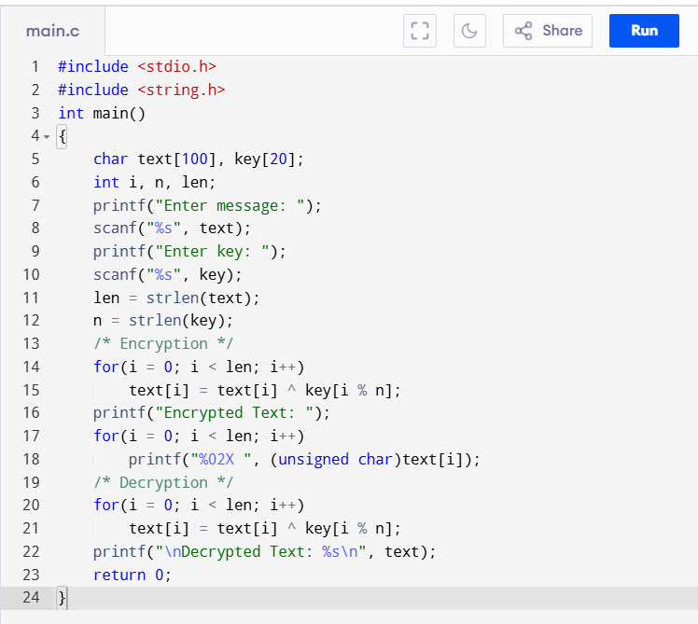
OUTPUT:
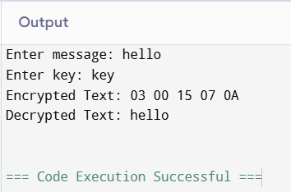
RESULT:
Thus, the RC5 encryption and decryption process was successfully demonstrated.

